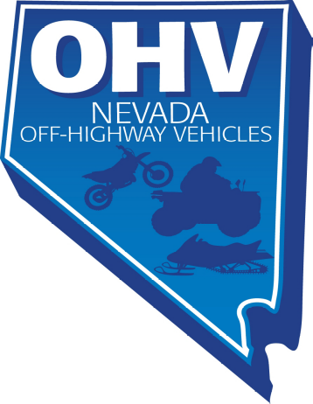
Nevada Commission on Off Highway Vehicles March 30, 2015
1615 South Virginia Street, Suite E, Box 163
Reno, Nevada 89502

To: Senator Hammond
Chairman
Senate Transportation Committee
From: Greg McKay
Chairman
Nevada Commission on Off Highway Vehicles
Subject: Support for SB 492

Mr. Chairman:
The Nevada Commission on Off Highway Vehicles supports SB 492.
The State of Nevada, Department of Administration, Division of Internal Audits, completed Audit Report No.15-01 in December of 2014. The audit recommended that the Nevada Commission on Off Highway Vehicles (Commission) should revise the current funding structure to maximize funds for off-highway vehicle (OHV) projects by seeking legislation that would allow the Department of Motor Vehicles (DMV) to transfer program fees in excess of DMV Program administrative expenses to the Commission.
Per statute, funds in DMV’s OHV operating account may only be used for paying administrative expenses related to titling and registration of OHV’s. Any amount of money remaining in the account is carried forward to the next year. This creates a reserve of idle OHV funds not permitted by statute to be used for any other purpose, including OHV projects.
At the current level of compliance, funds available to the DMV exceed its OHV program administrative expenses by almost $100,000 based on fiscal 2014 data. As much of DMV’s OHV program administrative expenses are fixed, expenses are not expected to increase proportionally as compliance levels increase. Over the long term at higher levels of compliance, the accumulated funds will almost match the commission’s annual apportionment.
This is but one area where the Commission is working well with the DMV. The audit also recommended that the commission work with the DMV to obtain better program revenue and expense data in order to verify the accuracy of their revenue allocation for increased transparency .We have agreed on a system that will be provided to the Commission on the first Monday of each month.
The commission is also working with the DMV on how to administer program’s to make it easier for residents and out-of-state residents to obtain vehicle inspections and registration decals. We have found the DMV to be a good partner who is genuinely interested in our success.
Our commission is working hard and is close to meeting the program’s goals. We appreciate your support.
In closing, we strongly urge passage of SB 492.

Sincerely,

Greg McKay
Chairman
Nevada Commission on Off Highway Vehicles
greg.e.mckay@gmail.com
775-690-3096

